Proactive Resilience of Urban Water Supply Cyber-Physical Systems under Extreme Water Network Malfunctions: An Early Warning Perspective
GRAPHICAL ABSTRACT
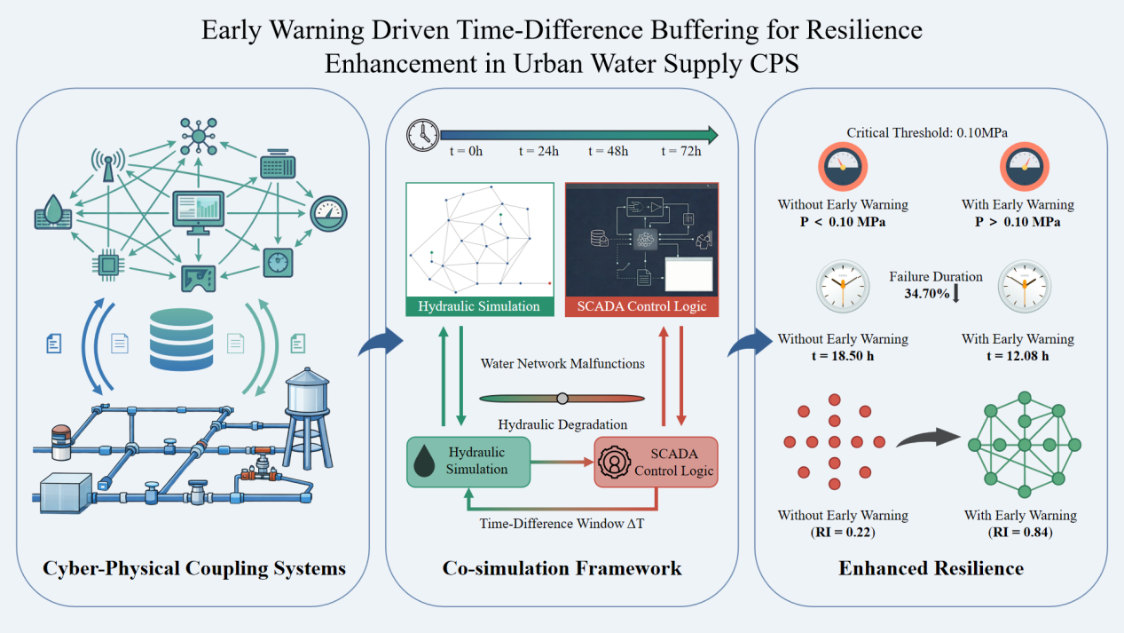
Abstract
Urban water supply lifeline systems exhibit cyber-physical coupling characteristics that offer significant sensing advantages for resilience enhancement. However, conventional assessment methods often overlook the time-difference buffer between rapid cyber sensing and gradual hydraulic degradation. Existing approaches are predominantly confined to the physical layer and rely on passive strategies, neglecting the potential of early warning mechanisms (EWM) to mitigate functional collapse. To address this limitation, this study develops a three-layer cyber-physical systems (CPS) model comprising physical, cyber, and coupling layers, and proposes a co simulation framework integrating hydraulic simulation with Supervisory Control and Data Acquisition (SCADA) monitoring logic. Taking the Anytown benchmark network under a water source interruption scenario as a case study, the systemic resilience evolution and graded risk transitions are quantified. Results demonstrate that implementation of an EWM produces a substantial resilience improvement, with the resilience index (RI) increasing from 0.22 to 0.84. The total supply failure duration is reduced by 34.70%, decreasing from 18.50 hours to 12.08 hours. Under EWM intervention, the average network pressure is maintained at 0.45 MPa, consistently exceeding the critical threshold of 0.10 MPa. Furthermore, a time-based performance compensation mechanism is identified: EWM extends the Critical and Alert states by 4.08 h and 2.00 h, respectively, thereby transforming brittle binary failure into a controllable buffering process. This study advances methodological innovation in urban lifeline resilience from a proactive EWM perspective and provides a scientific foundation for active risk management in urban water supply systems.
Keywords: Urban lifeline system, Water supply CPS, Resilience enhancement, Early warning, Time-difference buffer
1. Introduction
Resilience assessment of urban water supply systems is critical to public health, economic stability, and sustainable urban development under increasingly frequent disruptions (WHO, 2022; Savic and Banyard, 2024). With rapid digital transformation, conventional water supply infrastructures have evolved into complex cyber-physical systems (CPS) that integrate physical pipe networks with Internet of Things (IoT) sensors, Supervisory Control and Data Acquisition (SCADA) platforms, and automated control modules (Taormina et al., 2018; Mohebbi et al., 2020). This cyber-physical integration enhances operational efficiency through real-time monitoring and high-speed data transmission (Ande et al., 2020). More importantly, it provides a proactive sensing capability that enables the detection of physical anomalies before they escalate into systemic failures (Hassanzadeh et al., 2020; He et al., 2024). Therefore, elucidating the resilience evolution mechanisms and EWM potential of water supply CPS under extreme physical disruptions is essential for safeguarding urban lifeline infrastructure.
Existing resilience research on water supply systems has predominantly focused on characterizing physical disruptions such as pipe bursts, equipment degradation, and natural hazards using topological analysis and service availability metrics (Meng et al., 2018; Boltz et al., 2019; Sitzenfrei, 2021). Although these approaches effectively identify critical components within the physical layer, they largely neglect the speed disparity between rapid cyber sensing and the comparatively gradual propagation of hydraulic failures (Wu & Li, 2021; Alexandra et al., 2023; Chen et al., 2025). Most contemporary risk management frameworks continue to adopt passive fail-and-repair strategies and do not leverage the time-difference buffer inherent in cyber-physical interactions (Arghandeh et al., 2016; Khattak, 2024). As a result, a critical research gap remains in quantifying how high-speed cyber perception can be translated into actionable EWM windows to mitigate large-scale functional degradation, particularly under source-level disruptions such as water supply interruptions.
Establishing a high-fidelity co-simulation framework that integrates hydraulic modeling with SCADA monitoring logic provides a promising approach for investigating proactive resilience in water supply CPS (Yadav and Paul, 2021; Mignot and Dewals, 2022). However, three challenges remain unresolved: precise synchronization of heterogeneous cyber-physical temporal scales, quantitative representation of graded risk thresholds, and accurate measurement of the warning-to-collapse time-difference buffer (Wang and Shen, 2023; Sadien et al., 2024). In addition, the mechanisms through which EWM interventions delay performance degradation and enhance systemic resilience under source-level failures remain insufficiently understood. To address these gaps, this study examines resilience transition mechanisms and critical thresholds within a CPS framework and aims to establish a methodological foundation for graceful degradation and active defense in urban water supply lifeline systems.
This study develops a co-simulation framework that couples hydraulic modeling with SCADA control logic to investigate resilience enhancement in urban water supply CPS under water source interruptions. The research pursues three primary objectives: (1) to establish a three-layer cyber-physical co-simulation platform for analyzing system responses and identifying the time-difference buffer; (2) to construct a hierarchical risk framework comprising Warning, Alert, and Critical states and to quantify resilience improvement using the RI and temporal increments (ΔT); and (3) to elucidate the physical mechanisms of resilience enhancement through the strategic redistribution of risk-state durations. The principal contribution of this work lies in identifying a time-based performance compensation mechanism and quantifying the resilience improvement achieved through EWM. The findings provide a proactive cyber-physical perspective for risk management in urban water supply systems beyond conventional physical-layer analysis.
2. Materials and Methods
2.1 Study Object
To ensure reliability, reproducibility, and generalizability, the Anytown benchmark water distribution network was selected as the physical-layer testbed. Originally proposed by Walski et al. (1987) and widely adopted in resilience assessment, hydraulic simulation, and critical node identification studies (Meng et al., 2018), the network serves as a representative benchmark for medium-scale urban water supply systems. The network topology is presented in Fig. 1.
The physical layer comprises one reservoir node (R), two tank nodes (T1 and T2), twenty-two demand nodes (J1–J22), two pump stations (P1 and P2), and 45 pipes. The cyber layer is configured according to industrial SCADA practices and includes 8 programmable logic controllers (PLCs), 1 gateway, and 1 SCADA server, forming a star-topology monitoring and control network.
To quantify the system operational state under malfunction conditions, a hierarchical risk framework is established based on tank water levels (H) and nodal pressures (P). The operational status is classified into five levels: Normal, Warning, Alert, Critical, and Outlet Failure, each corresponding to a distinct hydraulic intervention window. The principal parameters of the CPS and the predefined risk thresholds are summarized in Table 1.

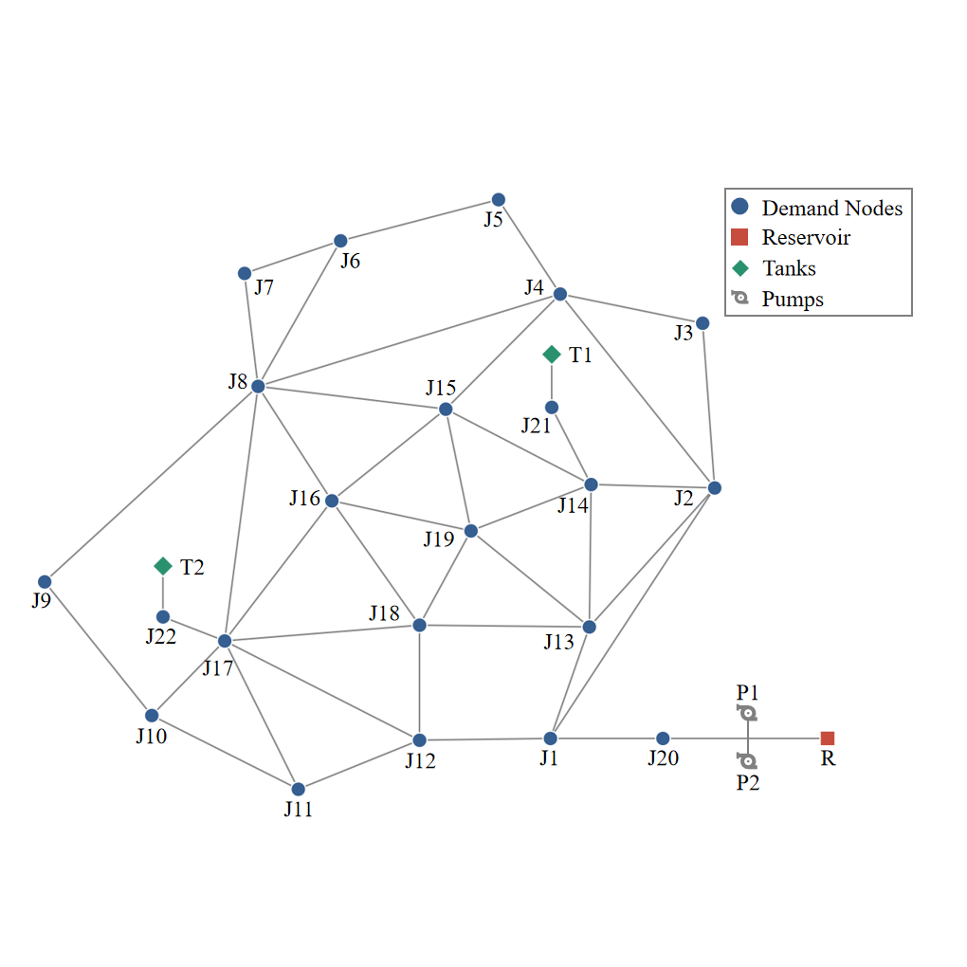
Fig. 1. Topology of the Anytown water distribution network.
Table 1. Key parameters and risk thresholds of the Anytown cyber-physical water distribution network.
Parameter Category | Component / Attribute | Value / Specification
Physical Infrastructure | Reservoir (R) | 1 node
 | Tank nodes (T1, T2) | 2 nodes (Max level = 10.668 m)
 | Demand nodes (J1-J22) | 22 nodes
 | Pumps (P1, P2) | 2 stations; ${\text{H}}_{\text{p}}\text{ =} {\text{a}}_{\text{0 }}\text{+} {\text{a}}_{\text{1}}\text{Q} \text{+} {\text{a}}_{\text{2}}{\text{Q}}^{\text{2}}$
Cyber Configuration | SCADA Infrastructure | 1 Server + 1 Gateway
 | PLCs | 8 units (Tank/Pump/Zone monitoring)
 | Communication | Star topology; Low-latency sensing
Operational Control | Pump logic | ON at $\text{H}\text{ ≤ 5.0}$ m; OFF at $\text{H} \text{≥}\text{ 8.0}$ m
 | Critical Pressure ($P_{min}$) | 0.10 MPa (GB 50013-2018)
Risk Thresholds (H) | Normal | $\text{H}\text{ ≥ 5.0}$ m
 | Warning | $\text{4.0 ≤ }\text{H}\text{ < 5.0}$ m
 | Alert | $\text{2.0 ≤ }\text{H}\text{ < 4.0}$ m
 | Critical | $\text{0.5 ≤ }\text{H}\text{ < 2.0}$ m
 | Outlet Failure | $\text{H} \text{<}\text{ 0.5}$ m
2.2 Urban Water Supply CPS Modelling
The urban water supply CPS adopts a three-layer architecture comprising the physical layer, the cyber layer, and the coupling layer (Fig. 2). The framework is designed to leverage the speed disparity between high-speed cyber sensing and the comparatively gradual propagation of hydraulic failures. This disparity generates a controllable time-difference buffer that enables the transition from brittle binary failure to graded buffering behavior, thereby enhancing system resilience under physical disruptions.
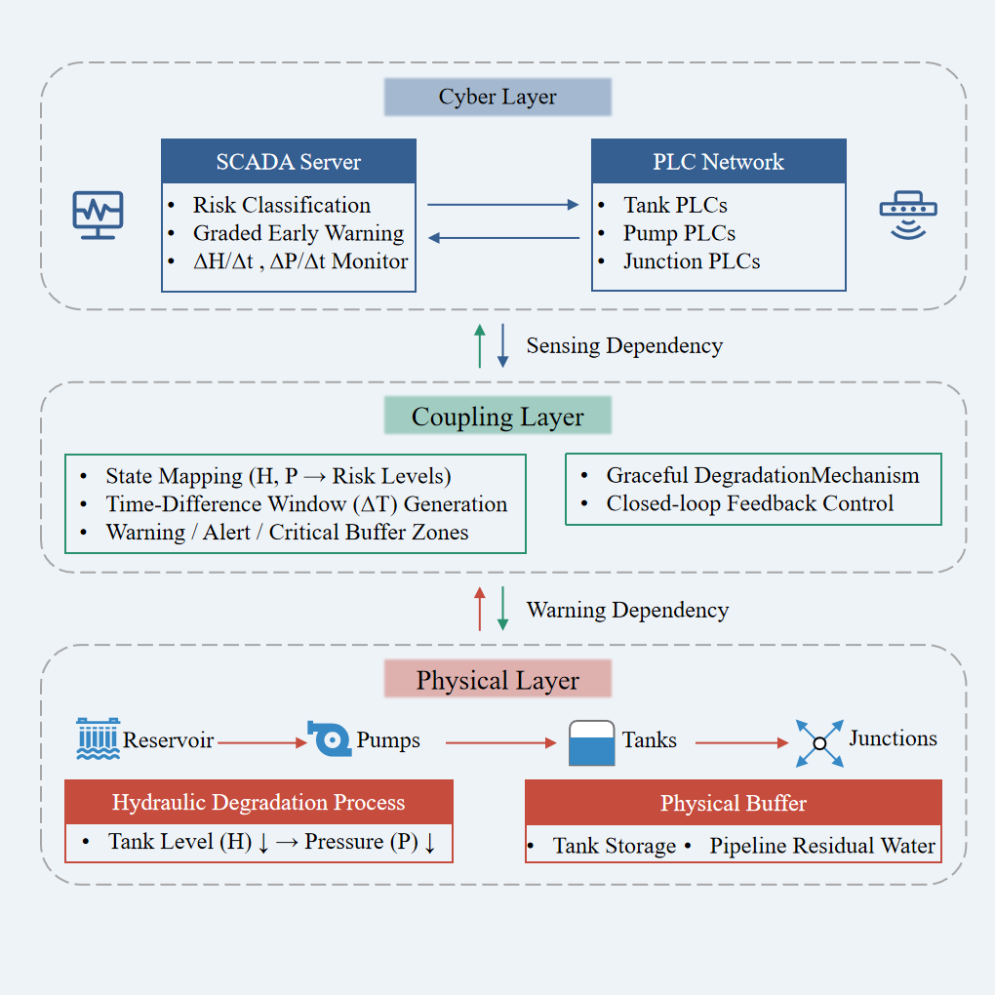
Fig. 2. Cyber-physical coupling framework of the urban water supply CPS. The framework consists of three hierarchical layers: (1) the physical layer providing hydraulic buffering capacity, (2) the cyber layer executing graded early warning based on real-time sensing of H and P, and (3) the coupling layer that transforms sensing speed advantages into a Time-Difference Window (ΔT), enabling graceful degradation and resilience enhancement.
2.2.1 Physical Layer Model
The physical layer functions as the hydraulic carrier and the source of resource redundancy. It is represented as a graph-theoretic network ${\text{G}}_{\text{p} }\text{= (}{\text{V}}_{\text{p}}\text{, }{\text{E}}_{\text{p}}\text{)}$, where ${\text{V}}_{\text{p}}$ denotes reservoirs, tanks, and demand junctions, and ${\text{E}}_{\text{p}}$ denotes pipes and pumps. In this study, tanks T1 and T2, together with residual water stored in pipelines, constitute the primary physical buffers.
Under disruption scenarios such as pump failure, the physical layer does not fail instantaneously but undergoes gradual degradation. Tank storage depletion precedes nodal pressure attenuation, resulting in temporal decoupling between water level drawdown (H) and pressure decay (P). This decoupling provides the physical foundation for EWM, as the system can maintain essential service levels above the critical threshold of 0.10 MPa by utilizing residual storage prior to complete depletion.
2.2.2 Cyber Layer Model
The cyber layer serves as the sensing and multi-stage decision-making center and is modeled as ${\text{G}}_{\text{c}} \text{= (}{\text{V}}_{\text{c}}\text{, }{\text{E}}_{\text{c}}\text{)}$, where ${\text{V}}_{\text{c}}$ represents cyber nodes and ${\text{E}}_{\text{c}}$ represents communication links. Consistent with industrial SCADA systems, the cyber layer performs high-speed state acquisition and classifies system risk according to the predefined thresholds listed in Table 1.
Beyond anomaly detection, the cyber layer implements graded EWM logic through continuous monitoring of tank level derivatives ΔH/Δt and nodal pressures. When H or P exceeds predefined thresholds corresponding to Warning, Alert, or Critical states, the SCADA server issues graded warning signals. This hierarchical decision structure enables early detection of malfunction evolution before the system reaches the Outlet Failure state, thereby supporting resilience-oriented intervention.
2.2.3 Coupling Layer Model
The coupling layer represents the dynamic closed-loop interaction between cyber and physical domains and operationalizes the time-difference window ΔT. It is governed by two interdependent mechanisms: sensing dependency, whereby the cyber layer continuously captures the physical state trajectory, and warning dependency, whereby cyber-derived warning signals are mapped to physical buffer stages.
Because cyber sensing operates at a substantially higher speed than hydraulic failure propagation, the coupling layer establishes graded buffer zones corresponding to Warning, Alert, and Critical states. This mechanism enables implementation of a graceful degradation strategy, whereby the time-difference buffer is strategically utilized to prevent cascading escalation from localized pump failure to systemic water supply interruption.
2.3 Malfunction Scenario Design
To investigate resilience evolution in the urban water supply CPS, a malfunction scenario based on total water source interruption is constructed. In this scenario, the disturbance originates from the sudden loss of supply at the reservoir (Node R), which prevents pumps P1 and P2 from replenishing tanks T1 and T2 regardless of their operational status. Unlike an instantaneous pipe burst within the distribution network, this source-level failure induces gradual hydraulic degradation. Although the primary supply is lost, the system can temporarily sustain basic service by relying on stored tank water and residual pipeline storage. The progressive depletion of these resources establishes a time-difference window, enabling the cyber layer to detect anomalies and issue EWM prior to complete functional failure.
The simulation is conducted over a 72-hour time horizon to capture both malfunction progression and recovery. The timeline is divided into three phases:
(1) Initial steady state (0–24 h): The system operates under normal conditions. The reservoir provides sufficient supply, and pump control maintains tank levels between 5.0 m and 8.0 m, establishing a stable baseline.
(2) Malfunction interval (24–48 h): A continuous water source interruption is imposed at t = 24 h and persists until t = 48 h. During this period, tanks T1 and T2 receive no replenishment, and their water levels (H) decline progressively in response to demand. The system sequentially transitions through the Warning, Alert, and Critical states defined in Table 1.
(3) Recovery phase (48–72 h): The water source is restored at t = 48 h. Pumps resume tank replenishment, and system performance progressively returns to steady-state conditions, enabling evaluation of recovery resilience.
Two comparative scenarios are analyzed. The Without EWM case represents the baseline condition in which degradation proceeds until tank storage is exhausted. The With EWM case evaluates how the EWM utilizes the time-difference window to mitigate the impacts of source interruption.
2.4 Co-simulation Platform Development
A hierarchical and weakly coupled co-simulation platform was developed in Python 3.13 to model the dynamic interaction between the physical hydraulic process and the cyber-layer monitoring logic. SQLite serves as a time-synchronized data exchange medium to ensure consistent information mapping between the physical and cyber domains, which is essential for capturing the time-difference window arising from gradual malfunction propagation.
The architecture comprises a physical simulation module and a cyber SCADA module. The physical module integrates EPANET 2.2 with the Water Network Tool for Resilience (WNTR) to perform dynamic hydraulic simulations using a fixed time step of 300 s. This configuration generates a continuous temporal sequence of state variables, including tank water levels (H) and nodal pressures (P), reflecting the progressive hydraulic degradation induced by source interruption.
The cyber SCADA module emulates an industrial monitoring framework and performs real-time state acquisition and multi-stage risk classification. Based on the predefined hierarchical thresholds, system states are categorized into five levels: Normal, Warning, Alert, Critical, and Outlet Failure. The module continuously evaluates trends in hydraulic variables and compares real-time measurements with threshold criteria to generate graded warning signals. These signals form the basis for analyzing temporal risk evolution and assessing the effectiveness of EWM in preserving functional buffering capacity prior to irreversible failure.
The platform operates through a standardized sequential execution protocol at each simulation step to ensure data consistency. First, the WNTR kernel invokes the EPANET solver to compute the hydraulic governing equations under the source interruption scenario and writes the resulting state variables to the SQLite database. The cyber module subsequently retrieves the updated states and performs risk assessment to determine the current operational level. The system records timestamps of all state transitions and accumulates the duration of each risk level over the 72-hour simulation period. These records provide the quantitative foundation for calculating the RI and time-difference increments (ΔT), thereby ensuring that the co-simulation framework directly supports multi-dimensional performance evaluation.

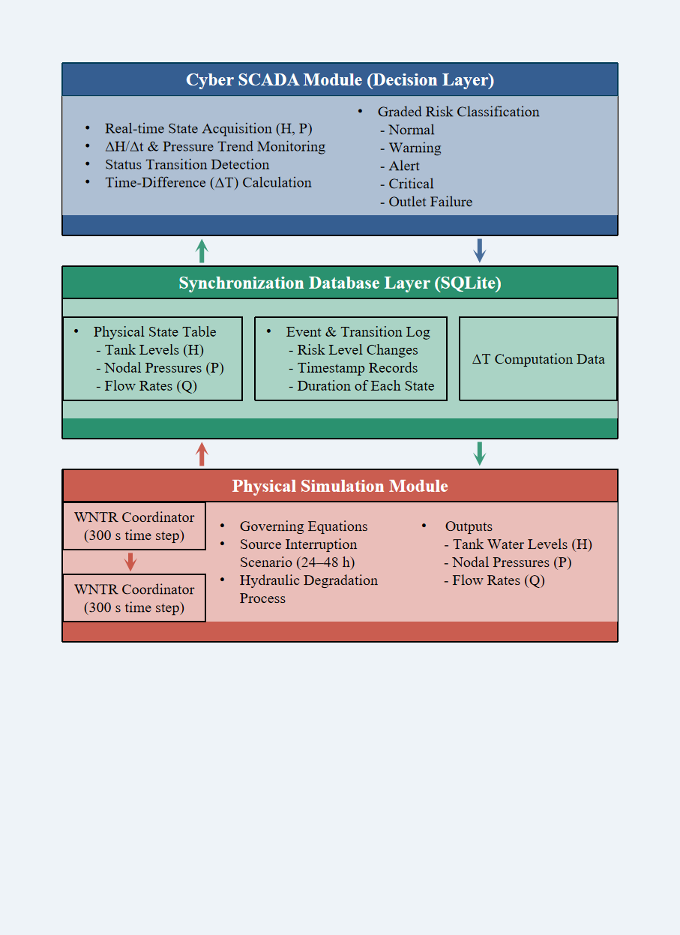
Fig. 3. Architecture of the integrated cyber-physical co-simulation platform for malfunction analysis. The platform adopts a hierarchical weakly coupled structure consisting of a physical simulation module (WNTR + EPANET 2.2), a time-synchronized SQLite database layer, and a cyber SCADA module implementing graded risk classification. At each simulation step (300 s), hydraulic states are computed, written to the database, and subsequently evaluated by the SCADA module to identify risk transitions and calculate Time-Difference increments (ΔT). This sequential execution mechanism ensures data consistency and provides the evidence chain for resilience index (RI) quantification.
2.5 Resilience Assessment Framework
Resilience, originating from ecology and systems theory (Holling, 1973), denotes the capacity of a system to maintain core functions, absorb disturbances, and recover to desired operational states (Hosseini et al., 2016; Juan-García et al., 2017; Cai et al., 2021; Liao et al., 2025). In this study, resilience is defined as the ability of the urban water supply CPS to withstand physical disruptions, sustain essential water supply services through tank storage and pipeline residual water, and recover efficiently after disturbance removal.
Unlike conventional reliability assessments, the proposed framework emphasizes dynamic transitions among graded risk states and the temporal compensation enabled by EWM. System performance is represented by a normalized continuous function $\text{P}\text{(}\text{t}\text{)} \text{∈} \left[\text{0, 1}\right]$, where $\text{P}\text{(}\text{t}\text{)}\text{ =1}$denotes full operational capacity under steady-state conditions and $\text{P}\text{(}\text{t}\text{)}\text{ = 0}$ denotes complete functional failure. Performance is primarily governed by nodal pressure adequacy. It remains at a high functional level while network pressure exceeds the critical threshold of 0.10 MPa, as specified in GB 50013-2018, and declines to zero when tank storage is exhausted (H < 0.5 m) or when pressure falls below the minimum service requirement. This formulation captures both the gradual nature of hydraulic degradation and the buffering effect of water storage, which are central to EWM-based resilience enhancement.
The RI is adopted as the principal integrated metric to quantify overall resistance and recovery performance during the 72-hour simulation period. It is defined as the ratio of cumulative actual performance to cumulative ideal performance over the interval from disruption onset ($t_{d}=24 h$) to full recovery ($t_{r}$):
$$\text{RI}\text{ =}\frac{\int_{{\text{t}}_{\text{d}}}^{{\text{t}}_{\text{r}}}{\text{[}\text{P}\text{(}\text{t}\text{) -}{ \text{P}}_{\text{m}\text{in}}\text{]}\text{dt}}}{\int_{{\text{t}}_{\text{d}}}^{{\text{t}}_{\text{r}}}{{\text{[}\text{P}}_{\text{ideal}}}\text{(}\text{t}\text{) -}{ \text{P}}_{\text{m}\text{in}}\text{]}\text{dt}}$$
Where $\text{P}\text{(}\text{t}\text{)}$ is the time-dependent system performance derived from hydraulic variables, ${\text{P}}_{\text{ideal}}\text{(}\text{t}\text{) = 1}$ represents ideal steady-state performance, and ${\text{P}}_{\text{m}\text{in}}=0$ denotes total service loss. This integral formulation quantifies cumulative performance loss during disruption and recovery. A higher RI indicates greater capacity to withstand source-level failure and more effective utilization of the time-difference buffer. The RI serves as the primary metric for comparing the baseline scenario without EWM and the intervention scenario with EWM.
To further examine the underlying mechanisms of resilience enhancement, secondary metrics are introduced. These include time-difference increments (ΔT) for each risk level, average network pressure (P), and average tank water level (H) during the malfunction interval. The time-difference increment for a given risk state is defined as the additional duration secured through EWM relative to the baseline case without EWM. Average hydraulic variables are computed using time-weighted integration to reflect sustained system performance during the 24-hour disruption period. By integrating the global RI metric with these temporal and physical indicators, the framework provides a comprehensive quantitative basis for evaluating how EWM redistributes risk-state durations and preserves pressure robustness.
3. Results
3.1 Temporal Evolution of Risk States
During the 24-hour malfunction period from 24 h to 48 h, the system risk levels progressed through distinct stages, and the implementation of the EWM significantly modified the timing of these transitions. As shown in Fig. 4(a), under the without EWM condition, storage tanks T1 and T2 transitioned from the Normal state (water level ≥ 5.0 m) through brief Warning and Alert stages to the Outlet Failure state (water level < 0.5 m) shortly after fault initiation at 24 h. In contrast, under the With EWM scenario, entry into the Outlet Failure state was delayed, and the state sequence exhibited oscillations between the Alert and Critical levels. The results indicate that the EWM prevented prolonged persistence in continuous failure throughout the malfunction period. Instead, the system maintained degraded but operational states for several additional hours relative to the baseline case, thereby postponing the most severe functional losses within the fault cycle.
Quantitative analysis of risk-state durations confirmed that EWM substantially reduced the total duration of complete supply failure. As illustrated in Fig. 4(b), the Outlet Failure durations for T1 and T2 without EWM were 18.42 h and 18.50 h, respectively, accounting for approximately 77% of the 24-hour malfunction interval. with EWM enabled, the failure duration for both tanks decreased to 12.08 h, corresponding to a reduction of approximately 34.70% in total downtime. These results demonstrate that the functional deficit was both delayed and reduced in magnitude. By decreasing cumulative residence time in the failure state, the EWM strategy preserved minimum operational storage levels for a greater proportion of the event, thereby improving service continuity under extreme conditions.
The reduction in total failure duration was accompanied by a redistribution of time into intermediate buffer states, namely the Alert and Critical levels. Fig. 4(b) indicates that time spent in the Critical state (0.5 m to 2.0 m) increased from 1.00 h under without EWM to 5.08 h under with EWM. Similarly, the duration of the Alert state (2.0 m to 4.0 m) increased from 0.67 h for T1 and 0.92 h for T2 to 3.33 h for both tanks with EWM activated. This temporal reallocation of the 24-hour malfunction interval indicates that the EWM enabled operation in a degraded yet functional regime rather than a binary normal–failure condition. By extending residence time within these intermediate states, complete depletion of storage was postponed. The altered temporal distribution of risk levels therefore enhanced operational buffering capacity and sustained network functionality as tank water levels approached the critical threshold.
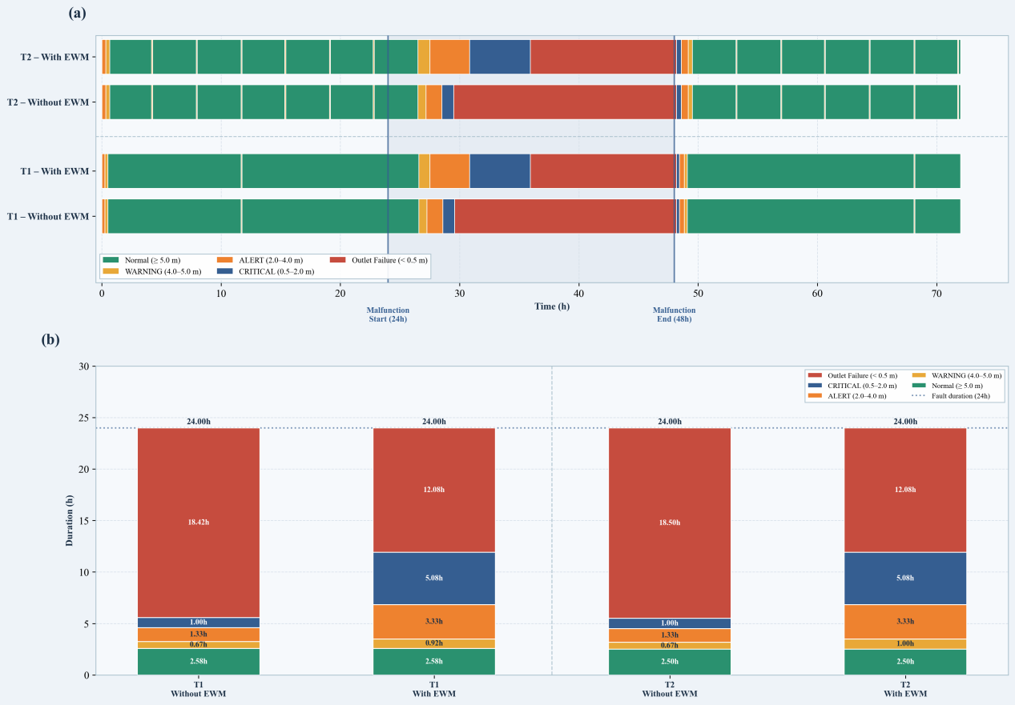
Fig. 4 Temporal evolution and duration distribution of risk states in storage tanks under Without EWM and With EWM conditions. (a) shows the temporal evolution of risk states, and (b) shows the duration distribution of various risk levels.
3.2 Hydraulic Response and Warning Buffers
Following malfunction onset, the average network pressure exhibited distinct dynamic responses, and the EWM effectively prevented systemic depressurization. As shown in Fig. 5, under the without EWM condition, the average pressure decreased sharply from 0.50 MPa to 0.00 MPa within approximately six hours after fault initiation at 24 h and remained at zero for the remainder of the malfunction interval. In contrast, with EWM intervention, the system stabilized at approximately 0.45 MPa after an initial decline and consistently remained above the critical threshold of 0.10 MPa. The shaded region in Fig. 5 represents the hydraulic performance preserved through warning intervention during the disruption period. These results demonstrate that the EWM mitigated network depressurization by regulating operational states and maintaining essential water distribution capacity throughout the emergency.
Core time windows secured for emergency response were quantified through analysis of warning trigger differentials. By correlating the trigger points in Fig. 5 with the statistical results in Table 2, the EWM was found to generate positive time increments (ΔT) across all risk levels. For tanks T1 and T2, the duration of the Warning state increased by 0.25 h and 0.33 h, respectively, while the Alert state duration increased uniformly by 2.00 h. The largest extension occurred in the Critical state, with an increase of 4.08 h. These temporal gains indicate that additional operational windows were created for implementing scheduling or maintenance measures before complete supply failure occurred. The results confirm that early warning transformed potential downtime into graded response intervals, thereby enhancing hydraulic buffering capacity.
A full-cycle comparison of hydraulic indicators further demonstrated the contribution of warning intervention to overall system stability. As summarized in Table 2, the average network pressure during the malfunction increased from 0.12 MPa without EWM to 0.45 MPa with EWM, corresponding to a net increase of 0.34 MPa. Concurrently, average water levels in tanks T1 and T2 increased from 1.14 m and 1.09 m to 1.64 m and 1.60 m, respectively, representing an approximate rise of 0.50 m. The consistent improvement in these hydraulic parameters indicates that the EWM not only extended temporal buffering but also preserved a higher hydraulic energy state. This stabilization reduced the risk of contaminant intrusion associated with depressurization and mitigated pressure fluctuations during post-disruption recovery after 48 h. Collectively, these results demonstrate that EWM enhanced distribution network robustness under extreme conditions by sustaining pressure and storage redundancy.
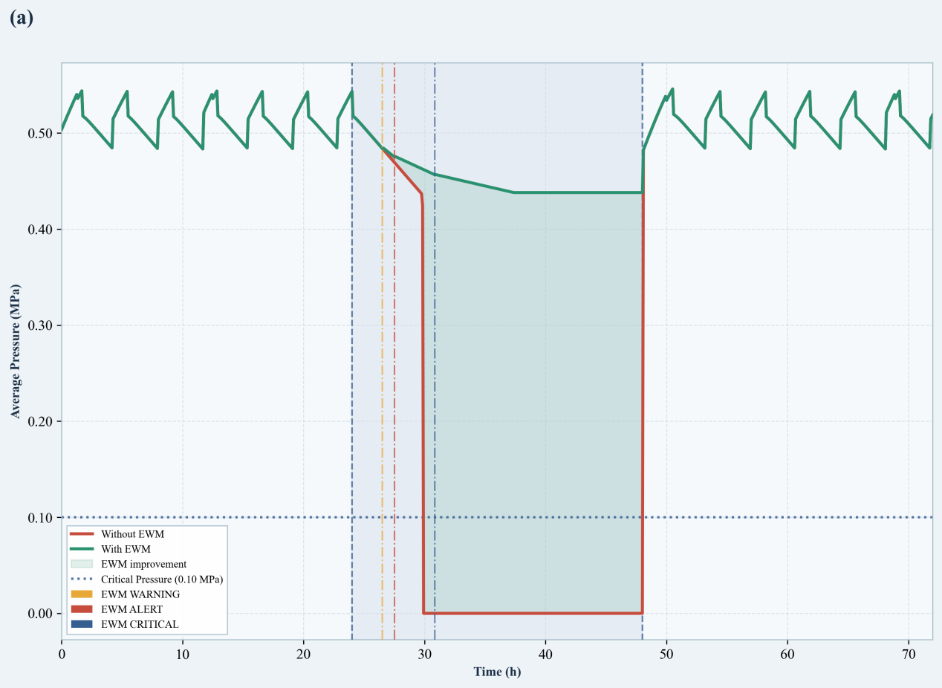
Fig. 5 Dynamic response of average network pressure during the malfunction period under Without EWM and With EWM conditions. The dashed line represents the critical pressure threshold.
3.3 System Resilience and Integrated Performance
The quantitative evaluation of the RI provided direct evidence of substantial enhancement in the system capacity to withstand disturbances through EWM intervention. As shown in Fig. 6, the RI under the without EWM condition was 0.22, indicating severe functional degradation under extreme malfunction. With EWM enabled, the RI increased to 0.84, corresponding to an absolute improvement of 0.62. This increase reflects a marked reduction in cumulative performance loss, as represented by the area under the degradation curve, and quantitatively captures the integrated contribution of EWM to maintaining water supply continuity. The increase in RI from 0.22 to 0.84 indicates a transition from high vulnerability to strong resilience, demonstrating improved capacity to absorb and mitigate disruption-induced performance losses.
A multi-dimensional comparison of hydraulic indicators further supported the physical basis of the observed resilience improvement. As summarized in Table 2, the average network pressure during the malfunction increased from 0.12 MPa without EWM to 0.45 MPa with EWM, yielding a net gain of 0.34 MPa. Concurrently, the average water levels in tanks T1 and T2 increased from 1.14 m and 1.09 m to 1.64 m and 1.60 m, respectively, corresponding to an approximate rise of 0.50 m. These results indicate that resilience enhancement did not arise from a single parameter but from coordinated improvements in hydraulic energy state, reflected by pressure, and resource storage, reflected by water levels. The consistent improvement across these physical dimensions reinforces the validity of the RI as an integrated performance metric and confirms that EWM preserved a higher operational baseline under extreme conditions.
Temporal performance increments further clarified the mechanism underlying resilience enhancement. Table 2 documents delays in the triggering times of key risk states, with the Critical state extended by 4.08 h and the Alert state extended by 2.00 h for both T1 and T2. When considered together with the observed RI growth and hydraulic parameter improvements, these temporal gains reveal a coherent mechanism: Warning and Alert windows secured during the early stage of malfunction slowed tank depletion, thereby extending the duration of the Critical buffering phase during the later stage of disruption. The consistency of these statistical findings across temporal indicators and integrated resilience metrics confirms the systemic effectiveness of EWM in delaying degradation and sustaining operational functionality.
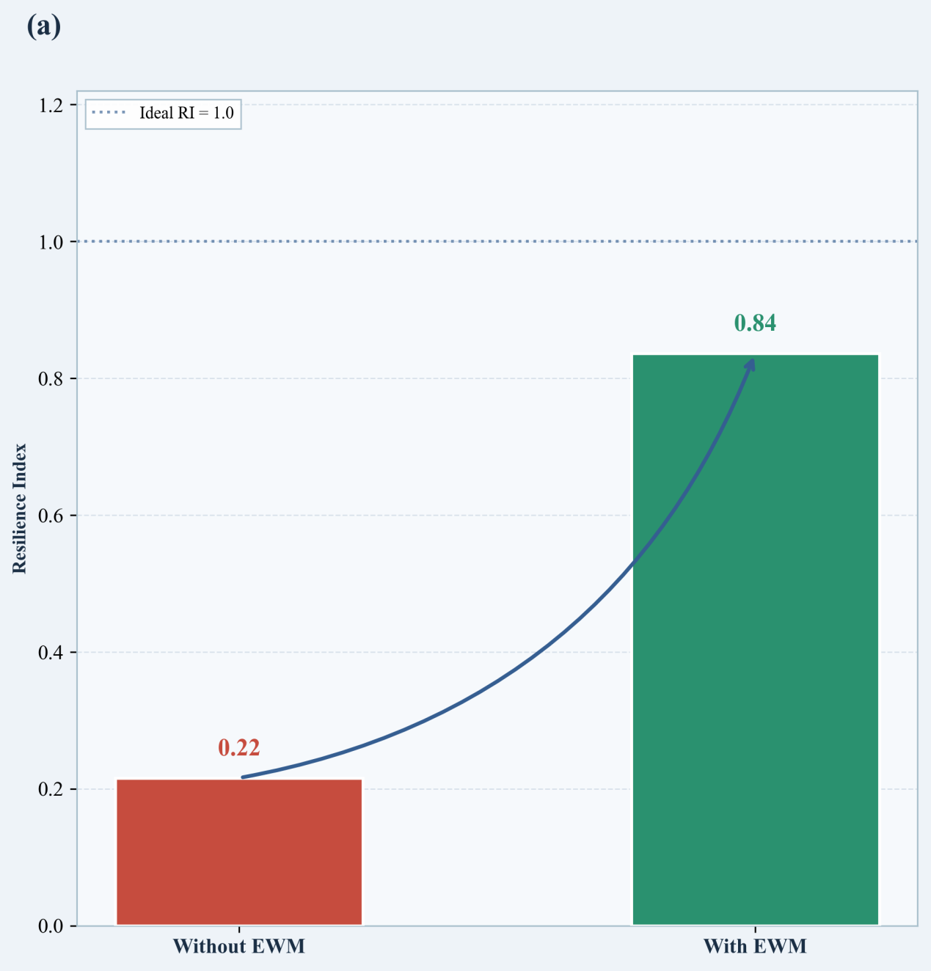
Fig. 6 Comparison of system Resilience Index (RI) under Without EWM and With EWM conditions. The dashed line represents the ideal RI value.
Table 2. Summary of multi-dimensional performance metrics under Without EWM and With EWM conditions. Δ represents the difference between With EWM and Without EWM, and positive values indicate improvement.
Performance Metric | Without EWM | With EWM | Δ (Improvement)
Resilience Index (RI) | 0.22 | 0.84 | +0.62
Average Network Pressure (MPa) | 0.12 | 0.45 | +0.34
T1 Water Level (m) | 1.14 | 1.64 | +0.50
T2 Water Level (m) | 1.09 | 1.60 | +0.51
T1 Warning State Duration (h) | 0.67 | 0.92 | +0.25
T2 Warning State Duration (h) | 0.67 | 1.00 | +0.33
T1 Alert State Duration (h) | 1.33 | 3.33 | +2.00
T2 Alert State Duration (h) | 1.33 | 3.33 | +2.00
T1 Critical State Duration (h) | 1.00 | 5.08 | +4.08
T2 Critical State Duration (h) | 1.00 | 5.08 | +4.08
T1 Outlet Failure Duration (h) | 18.42 | 12.08 | -6.34
T2 Outlet Failure Duration (h) | 18.50 | 12.08 | -6.42
4. Discussion
4.1 Mechanism of Resilience Enhancement by Early Warning
The increase in the RI from 0.22 to 0.84 was primarily driven by a time-for-resource allocation mechanism enabled by EWM. By initiating intervention at the onset of malfunction at 24 h, the system utilized storage tank redundancy to convert stored hydraulic potential into sustained network pressure support. Consistent with the widely recognized reliability-resilience-sustainability framework (Casal-Campos et al., 2018; Moreno-Sader et al., 2019; Zhang et al., 2025), the present mechanism demonstrates that regulated deployment of system reserve capacity plays a critical role in boosting absorption performance amid adverse disturbances and operational shocks. The 4.08 h extension of the Critical state observed in the results represents a quantitative manifestation of this temporal compensation process. Rather than responding passively to performance degradation, the system redistributed temporal resources to extend functional continuity through proactive operational adjustment.
Maintaining network pressure above the critical threshold of 0.10 MPa constituted the principal hydraulic barrier preventing cascading failure. Under the without EWM condition, pressure declined rapidly to 0.00 MPa, indicating complete supply interruption and increased vulnerability to contaminant intrusion and backflow induced by negative pressure. With EWM, average network pressure was sustained at approximately 0.45 MPa, preserving hydraulic stability during the disruption. As emphasized by (Cui et al., 2022; Zou et al., 2023; Zhang et al., 2024; Jiang et al., 2025), maintaining minimum operational pressure is essential for ensuring water quality safety and structural integrity under extreme conditions. By preserving pressure above the critical threshold, EWM confined system degradation to a controlled low-pressure regime and prevented escalation toward full network paralysis.
EWM also enabled a transition from brittle binary failure to graded buffering behavior, thereby enhancing operational fault tolerance. Conventional secondary water supply systems often exhibit binary performance states under pump failure, functioning either fully or not at all. The redistribution of risk-state durations observed in this study demonstrates the capacity for graceful degradation under disturbance. In accordance with the infrastructure resilience definition proposed by (Roach & Ledbetter, 2018; Zhang et al., 2022; Sun et al., 2022; Hou et al., 2023; Liu & Mijic, 2025), the deliberate trade-off between partial performance loss, reflected by tank level decline, and preservation of critical functionality, reflected by pressure maintenance, is characteristic of resilient systems. The multi-stage buffer states of Warning, Alert, and Critical provided structured decision windows for emergency response prior to total system failure. This operational mode shift indicates enhanced dynamic robustness, enabling the system to absorb external shocks through internal resource reallocation and temporal optimization.
4.2 Comparative Analysis of Multi-dimensional Metrics under Early Warning
This study demonstrates the advantages of employing multi-dimensional indicators, including water level, pressure, and temporal metrics, over single-metric assessments in evaluating EWM performance. Conventional resilience studies in water systems, such as (Liu, 2019; Liu et al., 2020; Chen & Sun, 2025), frequently emphasize network connectivity or demand satisfaction ratios while overlooking dynamic hydraulic evolution over time. As indicated by the comparative results in Table 2, an isolated increase in water level of approximately 0.50 m does not fully represent system recovery capacity. However, when combined with pressure preservation of 0.34 MPa and temporal extensions of up to 4.08 h, the integrated evaluation more accurately characterizes the resilience improvement achieved through EWM. This multi-criteria perspective is consistent with the multi-dimensional resilience framework proposed by (Xu et al., 2020; Liu et al., 2023; Madiziyire et al., 2025), which emphasizes coupling physical reserves with service pressure to reflect actual operational performance during extreme disruptions.
Under EWM intervention, maintaining terminal network pressure proved to be a more decisive resilience indicator than sustaining tank water levels alone. Although tank levels declined continuously during malfunction, optimized operational scheduling ensured that average network pressure remained above the critical threshold of 0.10 MPa. This observation supports the pressure-driven analysis framework discussed by (Liserra et al., 2014), which identifies pressure deficiency as an earlier and more service-critical indicator than complete water depletion. Comparative analysis indicates that the primary contribution of EWM lies in preventing the network from entering a zero-pressure condition, thereby avoiding the most severe functional consequences. Sustained pressure stability provides empirical support for prioritizing pressure redundancy in resilience-oriented design of urban secondary water supply systems under extreme disturbances.
The substantial increase in the RI from 0.22 to 0.84 further highlights the effectiveness of EWM as an information-based intervention compared with conventional hardware redundancy measures. As reviewed by Hosseini et al. (2016), resilience enhancement through physical redundancy, such as enlarging storage capacity or installing additional pump units, is often limited by spatial and economic constraints and tends to produce incremental improvements. In contrast, the present results indicate that EWM improved system resilience through spatiotemporal optimization of existing resources, without additional physical expansion. This strategy demonstrates that resilience gains can be achieved through algorithmic coordination and operational intelligence. For densely populated urban areas with limited infrastructure expansion capacity, information-driven response mechanisms represent an efficient pathway for strengthening resilience under constrained physical redundancy conditions.
4.3 Application Value and Limitations of Early Warning
The resilience improvements identified in this study provide a quantitative basis for decision support in smart water systems managing secondary supply malfunctions. The increase of 0.62 in the RI and the extension of more than four hours in the Critical state indicate that the proposed EWM enables a shift from reactive maintenance to condition-based proactive management. As discussed by (Khan et al., 2020; Bhardwaj et al., 2021; Wardropper & Brookfield, 2022), effective decision-support systems in smart water networks depend on minimizing sensing latency while maximizing operational response time. By incorporating the proposed mechanism into urban water management platforms, operators can utilize the extended response window for flow redistribution, activation of backup pumps, or maintenance scheduling prior to reaching failure thresholds. This information-driven approach offers practical value for reducing the risk of large-scale service disruption resulting from pump station failures, particularly in high-density residential areas where pressure stability is critical.
Despite the demonstrated resilience enhancement, several practical and conceptual limitations remain. The model assumes perfect warning accuracy; however, in real-world applications, sensor inaccuracies, communication delays, and data loss may generate false positives or missed alerts. As noted by (Taiwo et al., 2023), uncertainties in demand patterns and equipment degradation can influence threshold reliability. In addition, the present analysis focuses on a single malfunction type and does not address multi-point failures, complex hydraulic interactions, or large-scale power outage scenarios. Because the experiments were conducted on medium-scale secondary supply units, further validation is required to assess scalability, computational efficiency, and parameter transferability for large and topologically complex distribution systems. These uncertainties highlight the need for robust fault-tolerant strategies when deploying EWM in practice.
Future research should investigate integration of artificial intelligence and Digital Twin technologies to enhance adaptive response capability. The current framework employs fixed hierarchical thresholds; however, machine learning approaches could enable dynamic threshold adjustment based on real-time demand forecasting and historical operational data (Ahmadi et al., 2020). High-fidelity Digital Twin models may further improve representation of interactions between hydraulic processes and control logic, supporting optimization of scheduling strategies under cascading failure conditions. As emphasized by (Argyroudis et al., 2022; He et al., 2023; Garcia-Perez et al., 2023), digital transformation plays a central role in strengthening long-term infrastructure resilience. The integration of multi-source data analytics and adaptive control strategies may therefore enhance the operational flexibility of existing water supply systems. Such interdisciplinary advancement represents a promising direction for transitioning urban water infrastructure from passive disturbance tolerance toward adaptive and self-reinforcing resilience.
5. Conclusions
Urban water supply lifeline systems have evolved into complex CPS, where the speed disparity between rapid cyber sensing and gradual hydraulic degradation forms an exploitable time-difference buffer. Conventional resilience assessments focus on the physical layer and adopt passive strategies, overlooking the potential of EWM to mitigate functional collapse. To address this gap, this study aimed to elucidate the resilience enhancement mechanisms of EWM in water supply CPS under extreme water source interruption and establish a foundation for proactive risk management. A three-layer CPS model and a co-simulation framework integrating WNTR/EPANET 2.2 hydraulic simulation with SCADA logic were developed, with SQLite for time synchronization, and tested on the Anytown benchmark network via 72-hour comparative simulations.
Key results confirm significant resilience improvement by EWM: the RI increases from 0.22 to 0.84, shifting the system from high vulnerability to strong resilience. EWM reduces total supply failure duration by 34.70%, from 18.50 hours to 12.08 hours, and maintains average network pressure at 0.45 MPa, above the critical threshold of 0.10 MPa. A time-based compensation mechanism was identified: EWM extends the Critical and Alert states by 4.08 hours and 2.00 hours, respectively, converting binary failure into a controllable buffering process. It also increases average water levels of tanks T1 and T2 by approximately 0.50 m, preserving hydraulic stability and mitigating contamination risks.
Theoretically, this study advances lifeline resilience methodology by integrating cyber-physical coupling and EWM, quantifying the time-difference buffer between cyber sensing and physical degradation. Practically, it provides actionable guidance for smart water management, supporting emergency interventions in high-density urban areas. Limitations include the assumption of perfect warning accuracy, focus on a single malfunction type, and constraints of a medium-scale testbed. Future research will integrate artificial intelligence (AI) and Digital Twin technologies, optimize computational efficiency, extend the framework to composite disturbance scenarios, and validate it on large-scale networks for real-time resilience monitoring.

References
Alexandra, C., Daniell, K. A., Guillaume, J., Saraswat, C., & Feldman, H. R. (2023). Cyber-physical systems in water management and governance. Current Opinion in Environmental Sustainability, 62, 101290.
Ande, R., Adebisi, B., Hammoudeh, M., & Saleem, J. (2020). Internet of Things: Evolution and technologies from a security perspective. Sustainable Cities and Society, 54, 101728.
Arghandeh, R., Von Meier, A., Mehrmanesh, L., & Mili, L. (2016). On the definition of cyber-physical resilience in power systems. Renewable and Sustainable Energy Reviews, 58, 1060-1069.
Argyroudis, S. A., Mitoulis, S. A., Chatzi, E., Baker, J. W., Brilakis, I., Gkoumas, K., ... & Linkov, I. (2022). Digital technologies can enhance climate resilience of critical infrastructure. Climate Risk Management, 35, 100387.
Bhardwaj, J., Krishnan, J. P., Marin, D. F. L., Beferull-Lozano, B., Cenkeramaddi, L. R., & Harman, C. (2021). Cyber-physical systems for smart water networks: A review. IEEE Sensors Journal, 21(23), 26447-26469.
Boltz, F., Poff, N. L., Folke, C., Kete, N., Brown, C. M., Freeman, S. S. G., ... & Rockström, J. (2019). Water is a master variable: Solving for resilience in the modern era. Water Security, 8, 100048.
Cai, B., Zhang, Y., Wang, H., Liu, Y., Ji, R., Gao, C., ... & Liu, J. (2021). Resilience evaluation methodology of engineering systems with dynamic-Bayesian-network-based degradation and maintenance. Reliability Engineering & System Safety, 209, 107464.
Casal-Campos, A., Sadr, S. M., Fu, G., & Butler, D. (2018). Reliable, resilient and sustainable urban drainage systems: an analysis of robustness under deep uncertainty. Environmental Science & Technology, 52(16), 9008-9021.
Chen, B., Li, H., & Sun, G. (2025). Seismic resilience assessment method and multi-objective optimal recovery strategy for large-scale urban water distribution network system. International Journal of Disaster Risk Reduction, 127, 105689.
Chen, Z., Zhang, S., & Dui, H. (2025). Importance-based risk evaluation methodology in transportation cyber-physical systems. Frontiers of Engineering Management, 12(2), 291-304.
Cui, Z., Guo, W., & Zhang, T. (2022). Superposition control of extreme water levels in surge tanks of pumped storage power station with two turbines under combined operating conditions. Journal of Energy Storage, 56, 105894.
Garcia-Perez, A., Cegarra-Navarro, J. G., Sallos, M. P., Martinez-Caro, E., & Chinnaswamy, A. (2023). Resilience in healthcare systems: Cyber security and digital transformation. Technovation, 121, 102583.
Hassanzadeh, A., Rasekh, A., Galelli, S., Aez, M., Taormina, R., Ostfeld, A., & Banks, M. K. (2020). A review of cybersecurity incidents in the water sector. Journal of Environmental Engineering, 146(5), 03120003.
He, S., Zhou, Y., Yang, Y., Liu, T., Zhou, Y., Li, J., ... & Guan, X. (2024). Cascading failure in cyber–physical systems: A review on failure modeling and vulnerability analysis. IEEE Transactions on Cybernetics, 54(12), 7936-7954.
He, Z., Huang, H., Choi, H., & Bilgihan, A. (2023). Building organizational resilience with digital transformation. Journal of Service Management, 34(1), 147-171.
Holling, C. S. (1973). Resilience and stability of ecological systems. Annual Review of Ecology and Systematics, 4(1), 1-23.
Hosseini, S., Barker, K., & Ramirez-Marquez, J. E. (2016). A review of definitions and measures of system resilience. Reliability Engineering & System Safety, 145, 47-61.
Hou, B., Huang, J., Miao, H., Zhao, X., & Wu, S. (2023). Seismic resilience evaluation of water distribution systems considering hydraulic and water quality performance. International Journal of Disaster Risk Reduction, 93, 103756.
Jiang, L., Hu, Y., Li, H., Shao, X., Zhang, X., Kan, Q., & Kang, G. (2025). A cGAN-based fatigue life prediction of 316 austenitic stainless steel in high-temperature and high-pressure water environments. International Journal of Fatigue, 190, 108633.
Juan-García, P., Butler, D., Comas, J., Darch, G., Sweetapple, C., Thornton, A., & Corominas, L. (2017). Resilience theory incorporated into urban wastewater systems management. State of the art. Water Research, 115, 149-161.
Khan, R., Zakarya, M., Balasubramanian, V., Jan, M. A., & Menon, V. G. (2020). Smart sensing-enabled decision support system for water scheduling in orange orchard. IEEE Sensors Journal, 21(16), 17492-17499.
Khattak, Z. H. (2024). Cybersecurity vulnerability and resilience of cooperative driving automation for energy efficiency and flow stability in smart cities. Sustainable Cities and Society, 106, 105368.
Liao, C., Chen, X., & Gao, Z. (2025). Toward smart charging, synergistic infrastructure and storable grid for coordinated power and transportation systems. Frontiers of Engineering Management, 12(3), 704-709.
Liserra, T., Maglionico, M., Ciriello, V., & Di Federico, V. (2014). Evaluation of reliability indicators for WDNs with demand-driven and pressure-driven models. Water resources management, 28(5), 1201-1217.
Liu, D. (2019). Evaluating the dynamic resilience process of a regional water resource system through the nexus approach and resilience routing analysis. Journal of Hydrology, 578, 124028.
Liu, L., & Mijic, A. (2025). Performance-based resilience assessment in integrated water systems: challenges and opportunities. Journal of hydrology, 134042.
Liu, L., Zhou, X., Dueñas-Osorio, L., Stadler, L., & Li, Q. (2023). Hybrid wastewater treatment and reuse enhances urban water system resilience to disruptive incidents. Nature Water, 1(12), 1048-1058.
Liu, W., Song, Z., Ouyang, M., & Li, J. (2020). Recovery-based seismic resilience enhancement strategies of water distribution networks. Reliability Engineering & System Safety, 203, 107088.
Madiziyire, S., Stagner, J., Carriveau, R., Biswas, N., Johnson, K., & Fisk, A. (2025). Evaluation of response measures for water cutoffs using pressure driven analysis simulations. Water Research, 124737.
Meng, F., Fu, G., Farmani, R., Sweetapple, C., & Butler, D. (2018). Topological attributes of network resilience: A study in water distribution systems. Water Research, 143, 376-386.
Mignot, E., & Dewals, B. (2022). Hydraulic modelling of inland urban flooding: Recent advances. Journal of hydrology, 609, 127763.
Ministry of Housing and Urban-Rural Development of the People’s Republic of China. (2018). Standard for design of outdoor water supply engineering: GB 50013-2018 [S]. Beijing: China Planning Press.
Mohebbi, S., Zhang, Q., Wells, E. C., Zhao, T., Nguyen, H., Li, M., ... & Ou, X. (2020). Cyber-physical-social interdependencies and organizational resilience: A review of water, transportation, and cyber infrastructure systems and processes. Sustainable Cities and Society, 62, 102327.
Moreno-Sader, K., Jain, P., Tenorio, L. C. B., Mannan, M. S., & El-Halwagi, M. M. (2019). Integrated approach of safety, sustainability, reliability, and resilience analysis via a return on investment metric. ACS Sustainable Chemistry & Engineering, 7(24), 19522-19536.
Roach, T., Kapelan, Z., & Ledbetter, R. (2018). Resilience-based performance metrics for water resources management under uncertainty. Advances in Water Resources, 116, 18-28.
Sadien, M., Doorga, J. R., & Rughooputh, S. D. (2024). Assessment of tangible coastal inundation damage related to critical infrastructure and buildings: The case of Mauritius Island. International Journal of Disaster Risk Reduction, 114, 104909.
Savic, D. A., & Banyard, J. K. (Eds.). (2024). Water Supply and Distribution Systems. Emerald Group Publishing.
Sitzenfrei, R. (2021). Using complex network analysis for water quality assessment in large water distribution systems. Water research, 201, 117359.
Sun, H., Yang, M., & Wang, H. (2022). Resilience-based approach to maintenance asset and operational cost planning. Process Safety and Environmental Protection, 162, 987-997.
Taiwo, R., Ben Seghier, M. E. A., & Zayed, T. (2023). Toward sustainable water infrastructure: The state-of-the-art for modeling the failure probability of water pipes. Water Resources Research, 59(4), e2022WR033256.
Taormina, R., Galelli, S., Tippenhauer, N. O., Salomons, E., Ostfeld, A., Eliades, D. G., ... & Ohar, Z. (2018). Battle of the attack detection algorithms: Disclosing cyber attacks on water distribution networks. Journal of Water Resources Planning and Management, 144(8), 04018048.
Walski, T. M., Brill, E. D., Gessler, J., Goulter, I. C., Jeppson, R. M., Lansey, K., ... & Ormsbee, L. (1987). Battle of the network models: Epilogue. Journal of Water Resources Planning and Management, 113(2), 191-203.
Wang, B., & Shen, C. (2023). A time-varying observer-based approach to equilibrium estimation and compensation for synchronization of heterogeneous nonlinear cyber-physical systems. IEEE Transactions on Automatic Control, 68(10), 6176-6183.
Wardropper, C., & Brookfield, A. (2022). Decision-support systems for water management. Journal of Hydrology, 610, 127928.
World Health Organization. (2022) Guidelines for drinking-water quality: Fourth edition incorporating the first and second addenda. World Health Organization, Geneva.
Wu, G., & Li, Z. S. (2021). Cyber–Physical Power System (CPPS): A review on measures and optimization methods of system resilience. Frontiers of Engineering Management, 8(4), 503-518.
Xu, W., Zhou, X., Xin, K., Boxall, J., Yan, H., & Tao, T. (2020). Disturbance extraction for burst detection in water distribution networks using pressure measurements. Water Resources Research, 56(5), e2019WR025526.
Yadav, G., & Paul, K. (2021). Architecture and security of SCADA systems: A review. International Journal of Critical Infrastructure Protection, 34, 100433.
Zhang, C., Chen, R., Wang, S., Dui, H., & Zhang, Y. (2022). Resilience efficiency importance measure for the selection of a component maintenance strategy to improve system performance recovery. Reliability Engineering & System Safety, 217, 108070.
Zhang, J., Qiu, W., Wang, Q., Yao, T., Hu, C., & Liu, Y. (2024). Extreme water level of surge chamber in hydropower plant under combined operating conditions. Chaos, Solitons & Fractals, 178, 114362.
Zhang, Y., Yin, H., Liu, M., Kong, F., & Xu, J. (2025). Evaluating the effectiveness of environmental sustainability indicators in optimizing green-grey infrastructure for sustainable stormwater management. Water Research, 272, 122932.
Zou, X. Y., Peng, X. Y., Zhao, X. X., & Chang, C. P. (2023). The impact of extreme weather events on water quality: International evidence. Natural Hazards, 115(1), 1-21.

